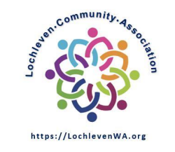
Date 10/4/2022
Board Meeting Minutes

Approval Statue: approved over email on 11/23

Meeting Starts: | 7:04
Meeting Ends: | 7:48

In attendance:
Board member | Others
- Scott Lampe
- Wayne Novak
- Yuan Zheng

Approval of previous meeting minutes:
Motion to approve 9/13 meeting minutes | Yuan
Second by | Scott
Vote
Result | All approve

Agenda items discussed
By law Committee update
- Initial committee meeting scheduled for 10/12
Halloween party planning update
- Yuan: beverages (hot chocolate & cider) ordering & serving
- Scott: face painting and membership checking
- Wayne: spin wheel & prizes
- Yuan: update website with details
Member meeting topics proposal
- Agenda: intro from each board member, by-laws update from by-laws committee, Halloween party update by Robin, city’s comm plan (invite special guest from city). Leave time for Q&A from members.
- Membership dues: according to the current by-laws, the renewal of membership due is charged in springtime. We will table this topic at the membership meeting.
- Proposed member meeting cadence to be second Tuesday of every even month. December 13th will be the next one
Membership Dues
- Current by-law defines to be collected on/before annual meeting, which is springtime
- We will table the original plan to collect dues at the end of calendar year for now
- The dues collection time should be a topic to be updated in the new by-laws
City’s one time mailer
- Use it for the next member meeting as part of the outreach

