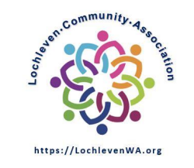
Date 12/07/2022
Board Meeting Minutes

Approval Statue: approved over email on 1/11

Meeting Starts: | 7:05PM
Meeting Ends: | 7:21PM

In attendance:
Board member | Others
- Scott Lampe
- Wayne Novak
- Yuan Zheng

Minutes

Officer Jordan Jackson Fund
- LCA made $200 contribution to the fund
- 5 LCA members reached out to thank the LCA board for this contribution
- An anonymous member contributed additional $300 to LCA and requested LCA to donate the $300 to officer Jordan’s fund.
- Yuan motion to approve the additional donation, Wayne seconded. The motion passed unanimously.

Dec Member meeting
- Proposed agenda.
  - City of Bellevue long term planning update by senior planner Kate Nesse
  - By-laws update by Steve McConnell (By-laws committee)
  - Financial/membership updates by Scott
- Zoom link and agenda will be emailed this week

Misc
- Membership update spreadsheet posted with ONEDRIVE and share among the board members
- Zelle cannot be added as a form of payment because it is not available with BECU business account
- USPS for LCA mailbox is too expensive. We will continue use Scott’s address.

